**Python: Version 3.6.2**

The Python download requires about 30 Mb of disk space; keep it on your machine, in case you need to re-install Python. When installed, Python requires about an additional 90 Mb of disk space.

**Downloading**

1. Click [Python Download](https://www.python.org/downloads/).

The following page will appear in your browser.

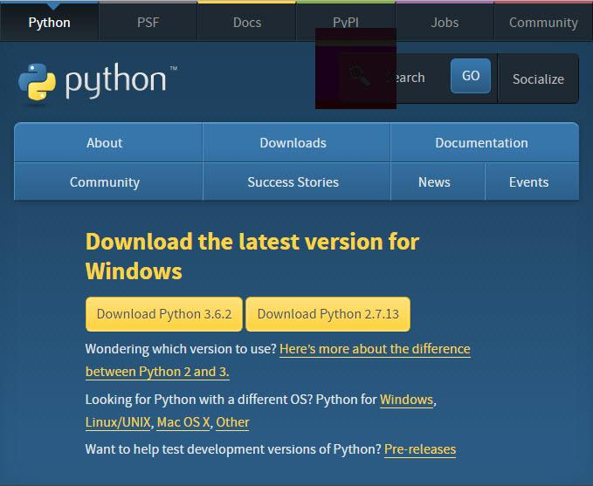

1. Click the **Download Python 3.6.2** button.

The file named **python-3.6.2.exe** should start downloading into your standard download folder. This file is about 30 Mb so it might take a while to download fully if you are on a slow internet connection (it took me about 10 seconds over a cable modem).

The file should appear as

https://www.ics.uci.edu/~pattis/common/handouts/pythoneclipsejava/images/python/exefile.jpg

1. Move this file to a more permanent location, so that you can install Python (and reinstall it easily later, if necessary).
2. Feel free to explore this webpage further; if you want to just continue the installation, you can terminate the tab browsing this webpage.
3. Start the **Installing** instructions directly below.

### **Installing**

1. Double-click the icon labelled as the file **python-3.6.2.exe**.

An “**Open File - Security Warning”** pop-up window will appear.

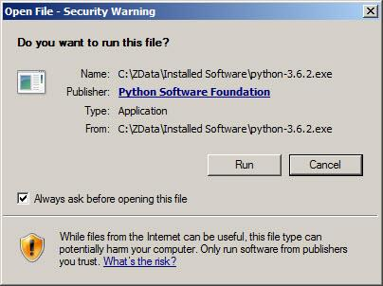

1. Click **Run**.

A **Python 3.6.2 (32-bit) Setup** pop-up window will appear.

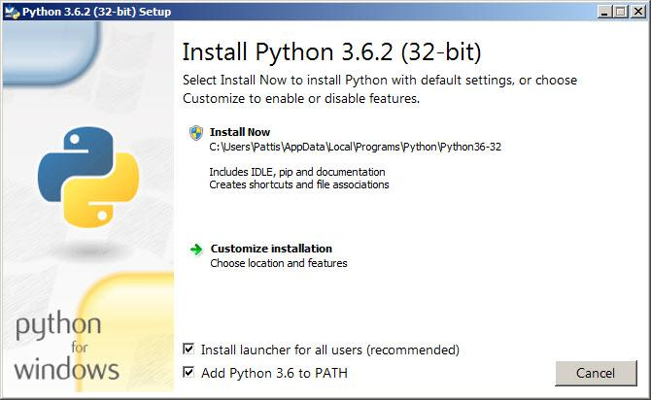

Ensure that the **Install launcher for all users (recommended)** and the **Add Python 3.6 to PATH** checkboxes at the bottom are checked.

If the Python Installer finds an earlier version of Python installed on your computer, the **Install Now** message will instead appear as **Upgrade Now** (and the checkboxes will not appear).

In this window click on Customize installation, then in the next window “install optional features” will appear. Select all the check boxes

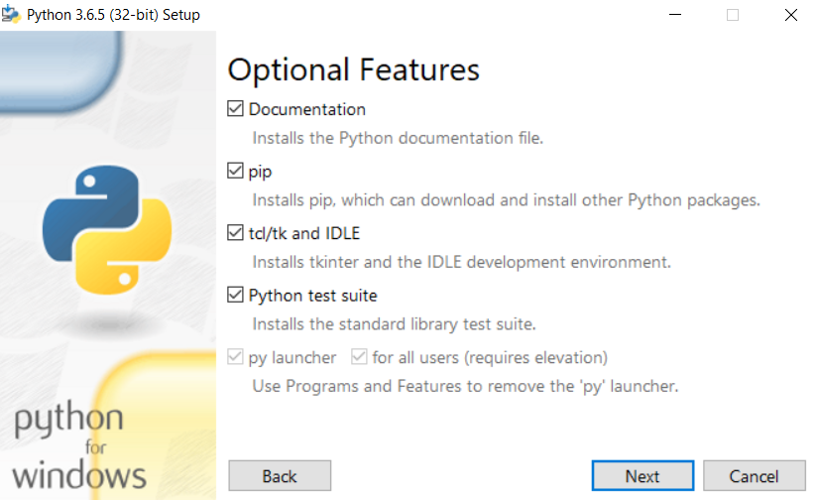

In the advanced option click on check boxes and click on browse and select C directory to install python then click install

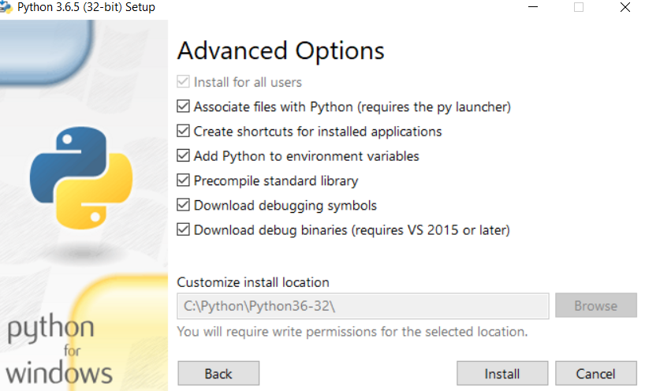

A User Account Control pop-up window will appear, posing the question Do you want the allow the following program to make changes to this computer?

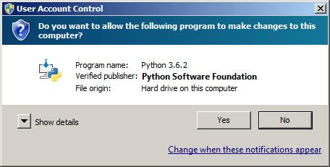

Click the **Yes** button.

A new **Python 3.6.2 (32-bit) Setup** pop-up window will appear with a **Setup Progress** message and a progress bar.

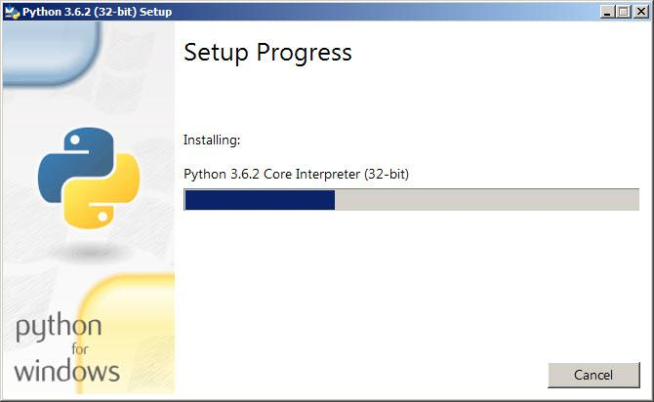

During installation, it will show the various components it is installing and move the progress bar towards completion. Soon, a new **Python 3.6.2 (32-bit) Setup** pop-up window will appear with a “**Setup was successful”** message.

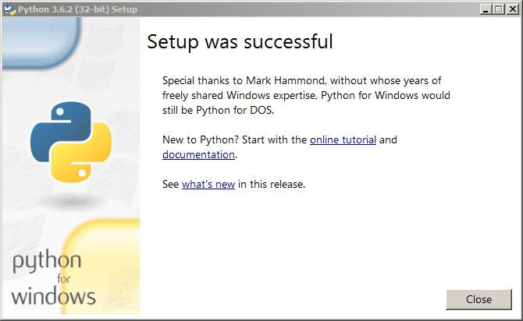

Click the **Close** button.

**Python is installed.**

For verifying the successful completion of the installation, go to “start” and you will find

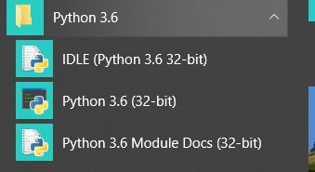

Installing of Packages:

Go to command prompt and then go to python installed directory

Place the requirement.txt file inside python directory

Enter this command: pip install -r requirement.txt

It will take minimum 10 minutes to install the packages if you find any error try re-entering the same command

*requirement.txt will be attached to manual.